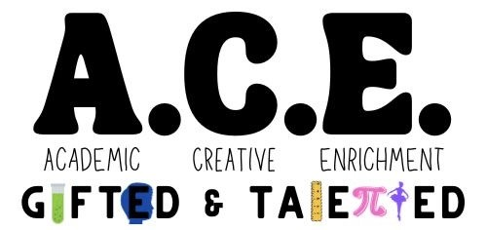

**Academic * Creative * Enrichment Syllabus**

**2025-2026**

**Course Description**

The gifted units of study will focus on developing cognitive learning, research and reference, and metacognitive skills at each grade level while using principles of differentiation.

**Instructional Philosophy**

The A.C.E. Program guarantees high academic achievement for all. The program ensures communication and collaboration within the community; while providing a safe, orderly, and healthy learning environment.

**Major Course Goal**

The overall goal of the gifted program is to provide each student with a minimum of five segments each week. Under this program, every identified gifted student will receive services that are in accordance with the GA. Department of Education (GADOE) requirements.

**Course Assessment Plan**

ACE students are given a variety of assessments using mostly rubrics during the course of each unit. Students will also evaluate and complete self-assessments.

**Classroom Expectations**

ACE students are to follow the expectations set forth in the RCBOE student code of conduct book. The students are also expected to follow all essential agreements from their designated school and by the gifted teacher. **The students are to complete all gifted work within the classroom and are responsible for all assignments from their grade level teacher(s).**

**Homework Policy & Grading Scale**

Homework is not a requirement for the A.C.E. Program. Students are not given a numerical grade for the report card, but their grade is derived from the completion of all course projects and classroom activities; performance task rubrics are utilized. The students' continued placement in the gifted program is based on their performance reports each year at meeting and/or exceeding the expectations. Gifted progress reports are distributed during the Fall and Spring of the year.

**Major Course Projects & Instructional Activities**

|  |  |
| --- | --- |
| **1st grade:**   * Exploring Diversity Around the World * I’m Some BODY Special (Study of organ systems) * Light and Sound * Secret Formulas (states of matter) * Animal Adaptations * Genius Hour – Year Long Project | **4th grade:**   * Forensic Science * Space Exploration * Aerodynamics * Theater Production * Greek Mythology * Genius Hour – Year Long Project |
| **2nd grade:**   * Fractured Fairytales (creative writing) * No Bones About It - Skeletal System * Poetry * Problem Solving * Tiny Town/Kid City * Genius Hour – Year Long Project | **5th grade:**   * Genetics * Electricity * Binary Number System * Study of Marine Life * History of Architecture * Genius Hour – Year Long Project |
| **3rd grade:**   * Inventions * The Nervous System * Cartooning & News Reporting * Problem Solving * Zoo Design & Simulation * Genius Hour – Year Long Project |  |

**Supplies and Materials Needed:**

* One - 1” Binder (new ACE students only)
* 1 pack of sheet protectors
* 1 subject spiral notebook for journaling (new ACE students only)
* **Personal:** pencils, color pencils, crayons, scissors, and glue sticks.

**Wish List Items**

* Paper towels
* Disinfectant wipes
* Facial tissue
* Hand sanitizer
* Ziploc bags (Science is messy!) Quart or Gallon sized

** Throughout the year, I may send home “wish” items or supplies that may be needed based on the unit of study.

**I can be reached at the following:**

**Gifted Teacher Name**: Jennifer Harman

**Email**: harmaje@boe.richmond.k12.ga.us

**phone Number**: McBean Elementary - 706-592-3723

**Please connect to Class Dojo for messages and important announcements/reminders.**